What is Inheritance?
Inheritance in Java is a mechanism where one class (child or subclass) can acquire properties and behaviors (fields and methods) of another class (parent or superclass).
It promotes code reusability, method overriding, and establishes a hierarchical relationship between classes — a fundamental part of Object-Oriented Programming (OOP).
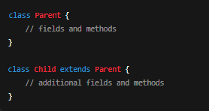
Syntax:

Why Use Inheritance?
- Code Reusability – Reuse existing class logic instead of writing again.
- Maintainability – Easier to manage and modify shared logic.
- Polymorphism – Enables overriding methods for flexible and dynamic behavior.
- Scalability – Allows hierarchical structures (common in enterprise codebases).

TYPES OF INHERITANCE IN JAVA
There are 5 major types of inheritance in OOP, but Java supports only 3 through classes, and the remaining 2 through interfaces.
- Single Level
- Multi-Level
- Multiple (not supported in Java Classes)
- Hierarchical
- Hybrid (not supported in Java Classes)

NOTE :
- Parent class is also known as Supper class or Base class
- Child class is also known as Sub class or Derived class

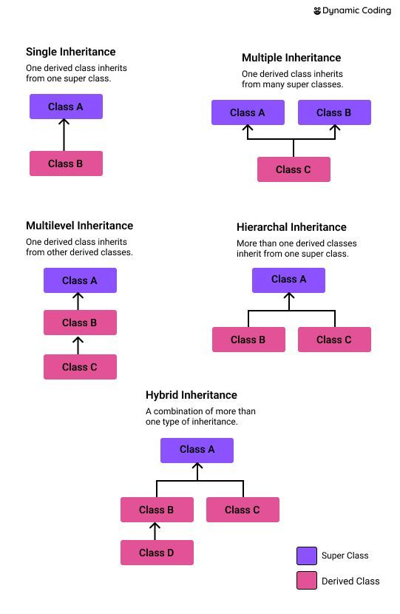

1️⃣ Single Inheritance
📘 Definition:
When a child class inherits from a single parent class.
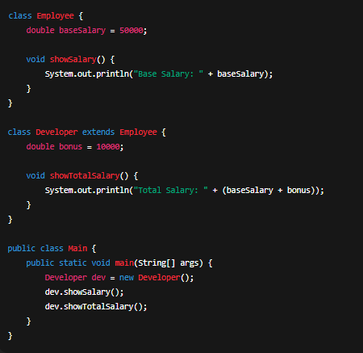
📖 Example (Industrial Level):
Suppose we are building a Payroll System.
We have a base class Employee and a subclass Developer.
Most real projects — e.g., User → AdminUser, Account → SavingsAccount

2️⃣ Multilevel Inheritance
📘 Definition:
When a class is derived from another derived class — forming a chain.
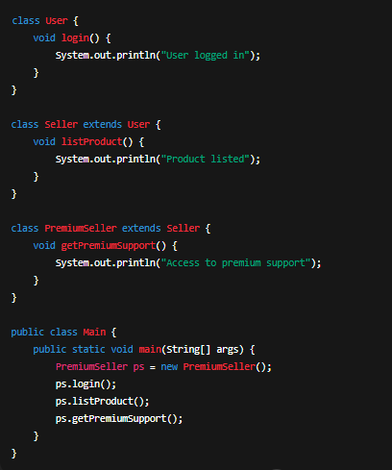
📖 Example (Industrial Level):
Used in E-commerce systems – User → Seller → PremiumSeller
Role hierarchies — like Employee → Manager → Director.

3️⃣ Hierarchical Inheritance
📘 Definition:
When multiple classes inherit from a single parent class.
📖 Example (Industrial Level):
In a Banking System – Account is the parent, and SavingsAccount, CurrentAccount are children.
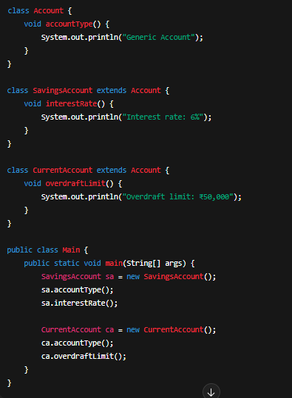
✅ NOTE:
Java does not support multiple inheritance using classes to avoid ambiguity and diamond problem.

4️⃣ Multiple Inheritance (via Interfaces)
📘 Definition:
When a class implements more than one interface.
This achieves multiple inheritance behavior safely — without ambiguity.
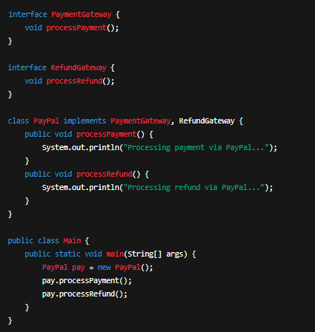
📖 Example (Industrial Level):
In a Payment System, a class can implement multiple capabilities.

Used In:
When a class needs to combine multiple functionalities (e.g., Logger, DatabaseConnectable).

5️⃣ Hybrid Inheritance (via Interfaces)
📘 Definition:
When two or more types of inheritance are combined together.
In Java, hybrid inheritance is achieved through interfaces (not classes).
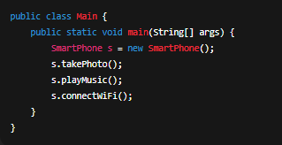
📖 Example (Industrial Level):
In a Smart Device System, combining multiple interfaces.
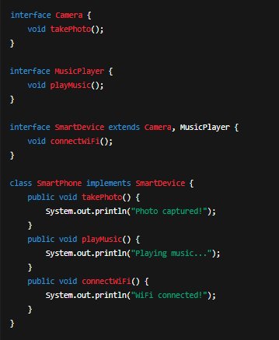
Used In:
Modern IoT or AI-enabled systems — where a class combines multiple feature modules.

Summary Table
Type of Inheritance | Supported by | Example | Real-life Use
Single | Class | Employee → Developer | Most OOP hierarchies
Multilevel | Class | User → Seller → PremiumSeller | Role-based systems
Hierarchical | Class | Account → SavingsAccount, CurrentAccount | Common base entities
Multiple | Interface | PayPal implements PaymentGateway, RefundGateway | Combining functionalities
Hybrid | Interface | SmartDevice extends Camera, MusicPlayer | Complex modular systems

Conclusion
👉 Java supports only 3 inheritance types via classes:
- Single
- Multilevel
- Hierarchical
👉 The other 2 types (Multiple & Hybrid) are achieved using Interfaces, maintaining flexibility and avoiding ambiguity.

